Geometry: Area of a Circle

Exploring the Relationship Between a Circle and a Parallelogram

Exercise 1
Below are three congruent circles that are sliced into six, eight, and twelve slices, respectively, and then unraveled and rearranged to form a new shape.

Chart A
 | Six Slices | Eight Slices | Twelve Slices
Circle | 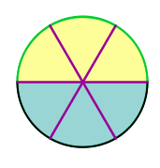 | 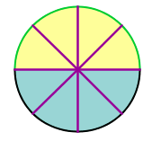 | 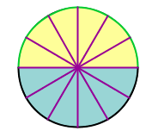
Unraveled Circle | 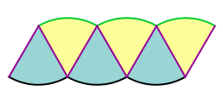 | 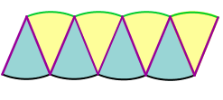 | 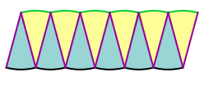

(a) Describe any patterns you notice in the unraveled circles as the slices become smaller and smaller:
__________________________________________________________________________________________________________________________________________________________________

(b) As the circle is cut into more and more slices, what shape does it begin to resemble? ______________

(c) Do you think it is possible to cut the circle into so many tiny pieces that when we unravel it, it becomes a perfect rectangle with four 90 degree angles and four straight edges? Explain why or why not. __________________________________________________________________________________________________________________________________________________________________

Deriving the Area of a Circle

Exercise 2
The figures below illustrate the relationship between the perpendicular height of the unraveled figures and the radii of the circles.

Chart B
Figure 1  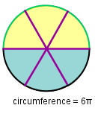  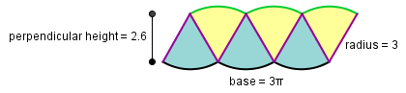 | Figure 2  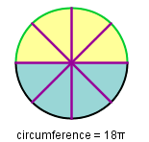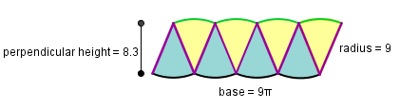
Figure 3  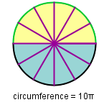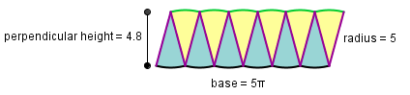 | Figure 4  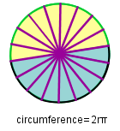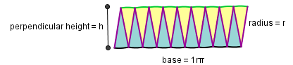

(a) Type the following program into the ChIDE and run it to calculate the percent difference between the perpendicular height and the radii of all four circles. Record the results in the table below.

Program 1
//Initialize variables
double radius, height, percent_difference;
//Get values
printf("enter the radius: ");
scanf("%lf", &radius);
printf("enter the perpendicular height: ");
scanf("%lf", &height);
//Calculate percent difference
percent_difference = 100*(radius - height)/radius;
//Display results
printf("percent difference: %.2lf %",percent_difference);

 | Figure 1 | Figure 2 | Figure 3 | Figure 4
Circumference | 6*pi |  |  | 2*pi*r
Length of Base | 3*pi | 9*pi
Radius |  |  | 5
Perpendicular Height | 2.6
Percent Difference between Radius and Height | 13.33% |  |  | (Hint: Try this by hand; your answer should be in terms of h and r.)

(b) Describe any pattern you see between the length of the circle’s circumference and the base of the unraveled circle: __________________________________________________________________________________________________________________________________________________________________

(c) Compare the radius to the perpendicular height of each circle. Which one is longer and why?
__________________________________________________________________________________________________________________________________________________________________

(d) Does the percent difference between the radius and the perpendicular height increase or decrease as we use more slices? _________________________________________________________________________________

(e) Imagine slicing the circle into 10,000 pieces and unraveling them. Based on the patterns you see in the figures above, would the percent change between the perpendicular height and the radius be really big or really small? Could we use the radius as an approximation of the perpendicular height? Why or why not? __________________________________________________________________________________________________________________________________________________________________

(f) Do you think we could have slices so small that the radius equals the perpendicular height? Explain: _________________________________________________________________________________

(g) The base of the outstretched circle is half of the circumference and the height is approximately equal to the radius. Recall, circumference equals 2(pi)(r). Using this information, write a formula for the area of the outstretched circle. The radius, r, should be the only variable in you answer.
A = __________________

Calculating the Area of a Circle

Exercise 3
Let’s now complete a Ch program that will calculate the area of a circle for you!

(a) Using the formula you just wrote, fill in the blank line so that Ch can calculate the area of a circle.

Note:
- Use the function pow(a,b) to raise a number ‘a’ to the power ‘b’.
- Ch uses the word ‘pi’ to represent the value of , or 3.14159...

Program 2
//Initialize variables
double r, area;
//Get the radius
printf("enter the radius: ");
scanf("%lf", &r);

//complete with the area of a circle equation with pi
area= ______;

//Display results
printf("area: %lf square units", area);

Type your code into the ChIDE editor and run it to calculate the area of the circles below, to the nearest ten thousandth.

Chart C
(b)  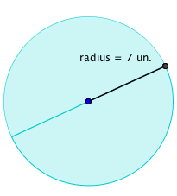  Area = __________ | (c)  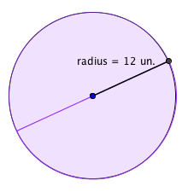  Area = __________ | (d)  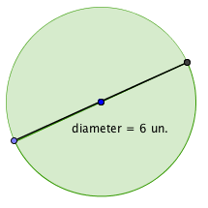  Area = __________

Notice that each of the circles below is missing a piece. In the chart below, explain how you would calculate the area of each circle with a missing piece (sector):
Chart D
Radius = 7 cm.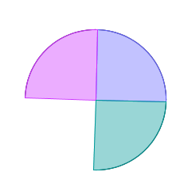 | Radius = 9 cm.  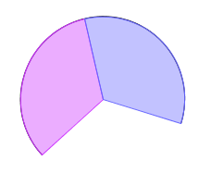 | Radius = 12 cm.  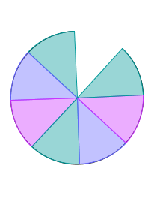
(e) Describe how to find the area of this circle with a missing slice: | (f) Describe how to find the area of this circle with a missing slice: | (g) Describe how to find the area of this circle with a missing slice:

Programming Ch to Calculate the Area of a Circle

Exercise 4
Use the method you described for each partial circle in the last activity to complete the Ch programs below. Then run each program to calculate the area of each partial circle.
Program 3
Chart E
Radius = 7 cm. | Radius = 9 cm. | Radius = 12 cm.
//Initialize variables  double r, area;  //Get the radius  printf("enter the radius: ");  scanf("%lf", &r);  //complete with the area of a circle equation  area = _______________________  printf("area: %lf square centimeters", area); | double r, area;  printf("enter the radius: ");  scanf("%lf", &r);  area = ______________________  printf("area: %lf square centimeters", area); | double r, area;  printf("enter the radius: ");  scanf("%lf", &r);  area = _______________________  printf("area: %lf square centimeters", area);
(a) area: __________________ | (b) area: _________________ | (c) area: __________________

(d) It is repetitive to change the program every time we remove a different size slice. In this last program below, Ch asks for the radius, the total number of slices, and the number of slices remaining. In your own words, explain how it will calculate the remaining area of any circle with any number of congruent slices removed. ______________________________________________________________________________________________________________________________________________________________________

Program 4
//Initialize variables
double r, area, oneslice;
int totalslices, remainingslices;

//Get values
printf("enter the radius: ");
scanf("%lf", &r);
printf("enter the total number of slices: ");
scanf("%d", &totalslices);
printf("enter the number of remaining slices: ");
scanf("%d", &remainingslices);

//Calculate area
oneslice = M_PI*r*r / totalslices;
area = oneslice * remainingslices;

//Display area
printf("area remaining: %.2lf square centimeters", area);

Use the program above to calculate the area of the following partial circles:

Chart F
Radius = 8 cm.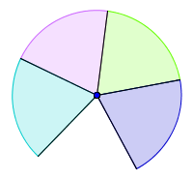 | Radius = 12 cm.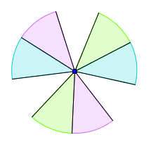 | Radius = 5 cm.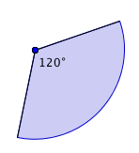
(e) area remaining: __________ | (f) area remaining:__________ | (g) area remaining:__________

Building an Algorithm for the Formula of a Circle

Imagine that you were living in the 1600s. Back then, people knew how to calculate the area of rectangles and parallelograms, however no one had figured out exactly how calculate the area of a circle. Write an algorithm that people from that time period could follow to derive the formula for the area of a circle.

_________________________________________________________________________________________________________________________________________________________________________________________________________________________________________________________

Copyright and License
Copyright 2014, SoftIntegration, Inc. http://www.softintegration.com

The content of this lesson is licensed under the Creative Commons Attribution 3.0 License, and code samples are licensed under the Apache 2.0 License.

